ENHANCING PROFITABILITY AND CUSTOMER SATISFACTION AT MADRAS METTALURGICAL SERVICES PRIVATE LIMITED : A FOCUS ON REVAMPING PROCUREMENT APPROACHES AND SALES EFFICIENCY

**A MID Term Submission report for the BDM capstone Project**

Submitted by

Name: **Ramprasad R**

Roll number: **21f1003573**



IITM Online BS Degree Program,

Indian Institute of Technology, Madras, Chennai

Tamil Nadu, India, 600036

**INDEX**

Executive Summary 2

Proof of Originality 3

Data Collection 4

Retention/Return Of Equipments 4

Sales of Equipments 6

Equipment Procrument 8

Detailed Explanation of Analysis Process 9

Meeting with Owner 9

Meeting with Employees 9

Results and Findings 10

# EXECUTIVE SUMMARY

This report provides an analysis of various aspects of a private business which specializes on selling products and equipment’s based on metallurgy, focusing on issues related to equipment retention and storage, sales of equipment’s, and equipment procurement i.e basically identifying the seller for a specific equipment. The **data was collected** through meetings with the owner and employees which turned out to be hugely pivotal to this entire process. The findings aim to identify key problems and suggest potential solutions for the business to introspect their current approach and work efficiently as an unit.

Regarding **equipment retention and return** , the analysis reveals that the return percentage can be considered to be less compared to accepted equipment’s .One can further see that most of the returned products/equipment’s are those which aren’t big or huge in terms of volume or size.Hence to address this issue suggestion can be such that there is no need to buy a separate storage space for storing these equipment’s but rather a small room can be provided for storing this.

The sales data for equipment’s indicates that Portable rebound Hardness tester,SCRM ductile (nodular) and spectrographic reference are the top revenue-generating items, while Sic Paper 8 has the highest average quantity sold. ATB-1 rechargable battery pack , on the other hand, has a lower average quantity sold, suggesting lower popularity. Exploring alternative options like providing complementary offers etc and by following new approaches in this industry like by developing an android application and providing it to customer’s can reduce workload and increase sales.

In terms of equipment procurement, the analysis shows that some new supplier’s tend to provide the same equipment at lower cost and nearly 5 supplier’s tend to provide almost 75 percent of the profit . Exploring new suppliers hence ,while ensuring quality could be a potential solution to address the issue of high supplier rates.

**Tools used** are all in Excel and Google Sheets with Charts and Formulas.

**Time period** is 5 months for all sort of data that is collected for this purpose.

The report concludes with recommendations, including cost-saving measures for storing returned product,following new methods for selling products. Additionally, it suggests considering the procurement of equipment from alternative suppliers to potentially reduce costs.

# PROOF OF ORIGINALITY

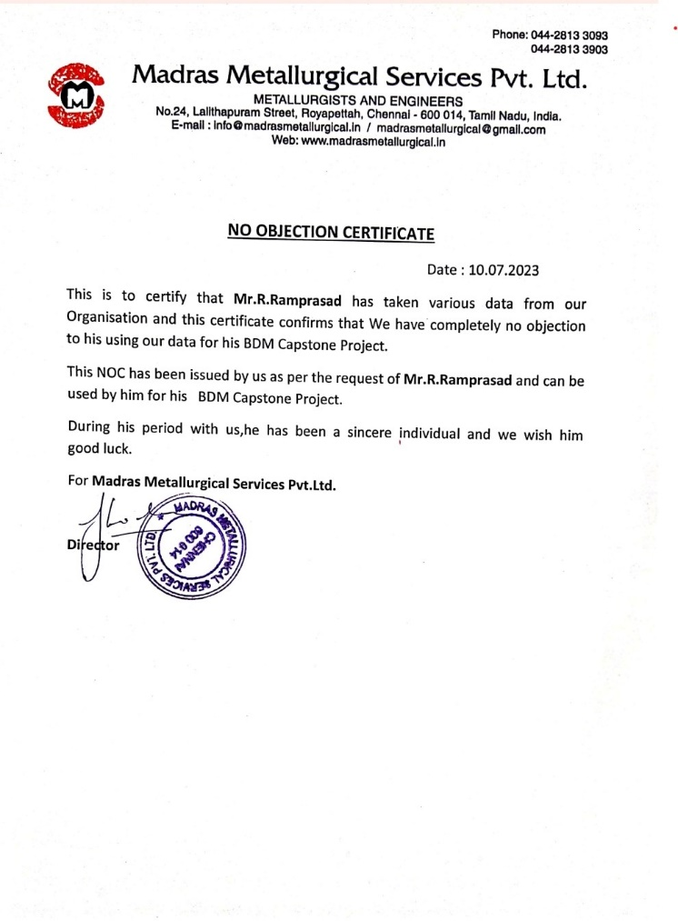 **Picture 1: NOC letter from organisation.**

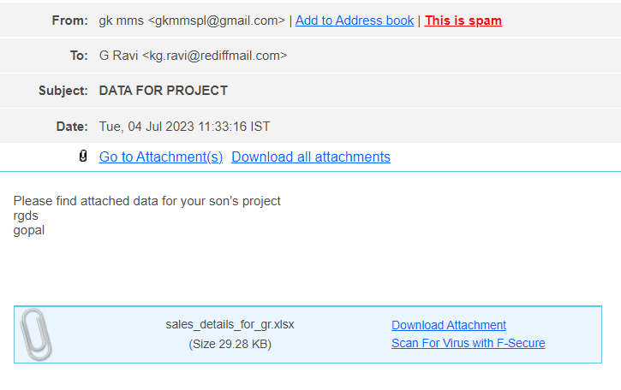

[Video Link](https://drive.google.com/file/d/1XqXoxXOQEejSsDBpl8ngP3c5OtOZZFTK/view?usp=drive_link)

**Picture 2:. Email From Company Head.**

# DATA COLLECTION

## RETENTION OF EQUIPMENTS

## [Link for the data collected:](https://docs.google.com/spreadsheets/d/1kjQP9xFSMgaM1XoRVo42pD-H3ULpjnMWfF5pbzE-008/edit?usp=sharing)

The first problem is of finding a possible approach to curb the problem of returned products.Address the issue of storage space and the cost associated with it.

1. **Product is returned or not-** So if a buyer makes any product purchase then if the buyer deems the product to be not upto the mark then he might return the product back to the company.
2. **If returned,what’s the procedure:** So if a product is returned then in most case it stays back with the company and not sent to the seller,the company’s engineer’s work on it to find the issues etc.

|  |  |
| --- | --- |
| **RETURNED** | **Numbers** |
| YES | 13 |
| NO | 93 |
| **Total** | **15** |

**Table 1: Return Data .**

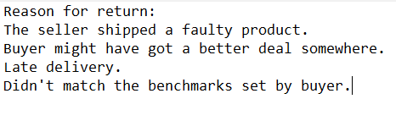

**Picture 3: Rough data provided by the owner of the firm as the reason for product return.**

### Metadata

* Data in above table is collected for a time period of **5 months** collected as part of their transaction and business with other entities . As can be seen in the above table the company sold/made 106 business transactions with buyer’s.Of that :
  + - Nearly 13 products were sent back to the company.(13 returns).
    - 93 products were accepted and not returned back to the company by the buyer’s.
* The data was provided in the form of a excel worksheet which was then used for this purpose.

### Descriptive Statistics

1. Number of Business Deals/Transactions:106
2. Total cost: ₹21,14,800

Breakdown by Return:

* 1. Yes:
     + Count: 13
     + Total Expenditure:Rs. 2,18,300
  2. No:
     + Count: 93
     + Total Expenditure:18,96,500
* One can see that easily the number of return’s is significantly less compared to the total . This can play a huge role in determining the need for a extra storage space for the returned products.The company averages nearly 2.6 return’s a month and the company’s success rate can be measured to be 87.7% . This are very good pointer’s for further analysis.

.

## SALES OF EQUIPMENT’S

## [Link for the collected data:](https://docs.google.com/spreadsheets/d/1Guz33GY8-c5nmWOFb0QGhLbx4ZzT8nA4ghDn1P2Nj1w/edit?usp=sharing)

The data in the aforementioned link contains all the data collected for this purpose-

|  |  |  |  |  |
| --- | --- | --- | --- | --- |
| **Date** | **Customer Details** | **Item** | **Qty** | **Selling Price** |
| **05.06.2020** | Jindal Saw ltd | Charts | 11 | Rs.14000 |
| **05.06.2020** | Nelcast Ltd | Poldi test bar | 5 | Rs.3250 |
| **05.06.2020** | Nelcast Ltd | Poldi test bar | 13 | Rs.8450 |
| **05.06.2020** | Safew tech | Specimens | 1 set | Rs.12500 |
| **08.06.2020** | Aerospace processing | Sic paper | 200 | Rs.6200 |
| **Total** | - | - | **230** | **Rs.44400** |

**Table 2: A sample of the population of data(Sales)**

|  |  |  |  |
| --- | --- | --- | --- |
| **Supplier details** | **Supplier Price** | **Profit** | **Profit Margin** |
| MMS | Rs 7000 | Rs 7000 | 50% approx. |
| BLUE STEEL | Rs 2500 | Rs 750 | 23% approx. |
| BLUE STEEL | Rs 6500 | Rs 1950 | 23% approx. |
| MODERN MET | Rs 9000 | Rs 3500 | 28% approx. |
| AUM VIJAYA | Rs 5000 | Rs 1200 | 19% approx |
| **Total:** | Rs 30000 | Rs 14400 | **_** |

**Table 3: A sample of the population of data (Buy)**

### Metadata

* Data collected for a **single month** which can be considered to be time series in nature.
* There are more than 1 sales on a single day and there are days where there are no sales.
* Item: The equipment/the product which is being sold.
* There is a separate column data which provides the date on which the equipment is sold to the buyer.
* Selling Price: The price at which the product(s) is sold.
* Total Sales: The total sales generated for each equipment.

**Descriptive Statistics**- Total Sales:

1. The item with the highest total sales is the Spectrographic reference Std.samples, which generated Rs.4,50,000 as revenue for the company.
2. The item with the lowest total sales is the Sulphur scale for carbon sulfur apparatus , which generated only Rs. 950 in sales .
3. Even though Spectrigraphic std.samples generated 450000 in revenue the profit generated by isn’t the highest but rather the profit generated by Charts without lamination is the highests at nearly 50%.
4. The product/item Sic paper sold the highest number of quantity as compared to other products at 200 while many equipement’s were sold only once this can attributed to their cost and their service life .
5. It can be noticed that almost 80 percent of sales returned a profit of nearly 25-35% .Products produced and sold by Madras Metallurgical services produced a profit of nealy 45-50 percent this can be something which is noted and further detailed accordingly.
6. Many customer’s returned and bought products again after a successful purchase of products.

## EQUIPMENT PROCRUMENT

[Link for the data sheet](https://docs.google.com/spreadsheets/d/1Guz33GY8-c5nmWOFb0QGhLbx4ZzT8nA4ghDn1P2Nj1w/edit?usp=drive_link)

The problem here is the high price set for equipment’s manufactured by different sellers over different period’s of time.

### Metadata

* Data collected for **5 months** and **Tools** used are of Google Sheets ,Excel,Python,Chart making, avg. formula calculation and analysis.
* Time period is from June 2020 to November 2020.
* It consists of date ,Item,Quantity purchased ,Supplier details and their price for each and every product/equipment.
* Got the data from the owner in the form of excel worksheet which was raw and required a lot of cleaning to be done for analysis to be performed.

### Descriptive Statistics

Rates:

* + Mean: ₹19950.94
    - On average, a business deal with a seller resulted in an amount of 19950.94 .
  + Median: ₹7000
    - The median represents the middle value of the supplier rates for equipment’s. From the analysis we can see that 50% of cost price is below 7000 and 50% above 7000.
  + Minimum: ₹500
    - The minimum value of 500 indicates the lowest recorded price of an item one can see that these products are manufactured by the firm themselves.
  + Maximum: ₹375000
    - The maximum value of ₹37500 represents the highest recorded price. **This is partially down to the fact that this product was exported from USA** and sold to the buyer.
  + Standard Deviation: ₹44511.34856
    - The standard deviation indicates the average amount of deviation of the product rates from the mean. In this case, it is pretty high, the average analysis done on the cost has means the buying is skewed in nature.

# DETAILED EXPLANATION OF ANALYSIS PROCESS

## MEETING WITH OWNER

* To get an in-depth knowledge about the business problems in general.
* Retention of “Equipment’s” is a significant problem along with the equipment suppliers and the number of equipment sales.
* With many sellers now preferring to directly sell the Equipment instead of using a mediator in between the buyer and the seller as resulted in a reduced amount of sales.
* Moreover with many competitive business’s opening shop in recent times and them following new approaches also can be a huge factor.
* An increase in the prices of raw materials required for the equipment design and build can be considered to be a major factor leading to this problem.
* Other things that were discussed were –
  + What about the idea and notion of giving freebies to new customer’s and gain their support and trust for future dealings.
  + Expanding the business by making foreign Export’s as they have Import and export license which many competitors don’t have .
  + Introducing new methods like developing mobile app’s per say.

## MEETING WITH EMPLOYEES OF THE FIRM

* Most of the employees live near the firm and according to them the business market as a whole as gone down over the years mainly due to the fact that over-competition of entities,many buyers prefer to use the product they bought before for some more time.
* Problems they mentioned –
  + They feel their main customer’s being colleges prefer to buy equipment’s that come in tango with supplementary tools and kits.
  + Some employees say that people learn business tricks and start a company elsewhere providing products at low cost resulting in buyers preferring them.

### Solution:

We can see from the data collected that total return’s as a proportion of total products bought is almost 13%.Even though there is a scope for reducing this even further this is a very good number for a business entity.One can take measures like :

* **Carefully choosing suppliers** this means basically choose suppliers who tend to provide better quality products as compared to supplier’s who tend to provide low quality products at lower cost’s as in the longer run this cost difference will become negligible compared to other expenses on the product.
* On further analysis one can see that some customer’s tend to return product’s more often.A word of caution can be to be extra careful while dealing with them

# RESULTS AND FINDINGS

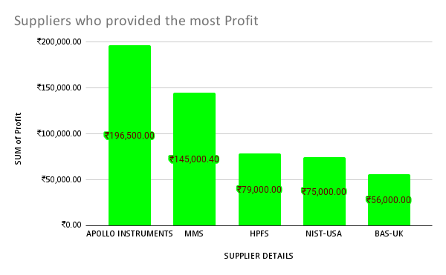

**Graph 1: Supplier’s vs profit.**

Key findings from the Graphs 1 made in [Google Sheets](https://docs.google.com/spreadsheets/d/1Guz33GY8-c5nmWOFb0QGhLbx4ZzT8nA4ghDn1P2Nj1w/edit?usp=sharing) and Table 3:

1. We can see that Apollo Instruments provided a profit of 1,96,500. On continuous observation one can find that the firm minted a profit of nearly 1,45,000 Rs by producing and selling its own products.Further import deals also turned out to be highly profitable considering the cost associated with shipping and other stuffs.This can be considered to be a huge analysis as aforementioned many competitors don’t have import and export license providing the firm with more opportunities to explore and work on a solution on the given lines.
2. Further one can consider this analysis to be a solution for selecting supplier’s, in the sense do a background check for suppliers on whether their product’s are efficient and profitable.
3. To better address the supplier problem ,**solution** would be to build / produce the products by themselves as Equipment’s of the company(Madras Mett. Services) origin created a huge revenue and profit.

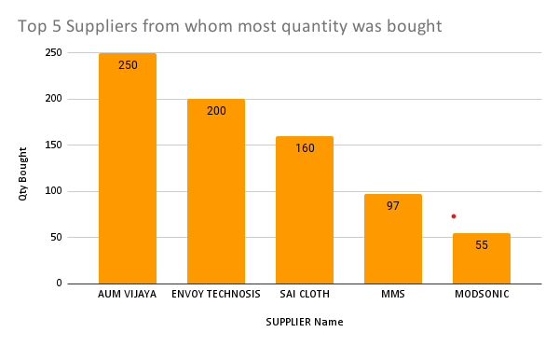

**Graph 2: Quantity vs Supplier.**

The above chart drawn from [Google Sheets charts](https://docs.google.com/spreadsheets/d/1Guz33GY8-c5nmWOFb0QGhLbx4ZzT8nA4ghDn1P2Nj1w/edit?usp=sharing) shows:

* AUM Vijaya provided more count of products .
* We can once again note here that MMS take’s 4th place in this list which further solidifies my solution that by following the policy of Building their own equipment’s and selling.This is a possible **solution** to both Supplier Problem and selling problem as if they produce products themselves they can do so in less cost thereby attracting more buyer’s.

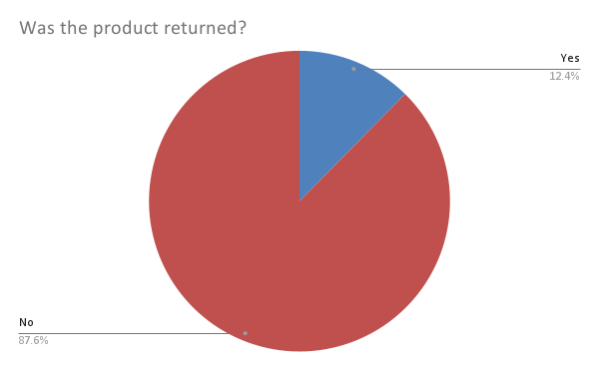

**Graph 3: Pie-Chart for comparison return (YES/NO).**

From this Graph 3 made in [Google Sheets](https://docs.google.com/spreadsheets/d/1Guz33GY8-c5nmWOFb0QGhLbx4ZzT8nA4ghDn1P2Nj1w/edit?usp=sharing) we can see that nearly 12.4%were returned by buyers as discussed in page 6.Due to small size no space is required